**RESERVE & READY**

**A PROJECT REPORT**

**for**

**Mini Project – I (K24MCA18p) Session (2024-25)**

**Submitted by**

**Disha Seth (20241011610064)**

**Ayushi Saran Singh (20241011610047)**

**Submitted in partial fulfilment of the**

**Requirements for the Degree of**

**Masters Of Computer Application**

**Under the Supervision of**

**Ms. Divya Singhal**

**Assistant Professor**



**Submitted to**

**DEPARTMENT OF COMPUTER APPLICATIONS**

**KIET Group of Institutions, Ghaziabad**

**Uttar Pradesh-201206**

**(DECEMBER- 2024)**

# CERTIFICATE

Certified that **Disha Seth 202410116100064, Ayushi Saran Singh 202410116100047** have carried out the project work having “**Reserve & Ready**” (**Mini Project-I, K24MCA18P**) for **Master of Computer Application** from Dr. A.P.J. Abdul Kalam Technical University (AKTU**)** (formerly UPTU), Lucknow under my supervision. The project report embodies original work, and studies are carried out by the student himself/herself and the contents of the project report do not form the basis for the award of any other degree to the candidate or to anybody else from this or any other Institution.

**Dr. Arun Kr. Tripathi**

**Dean**

**Department of Computer Applications**

**KIET Group of Institutions, Ghaziabad**

**Ms. Divya Singhal**

**Assistant Professor**

**Department of Computer Applications**

**KIET Group of Institutions, Ghaziabad**

# Reserve And Ready

**Disha Seth**

**Ayushi Saran Singh**

# ABSTRACT

The "Reserve and Ready" project is a reservation management system designed for wholesale and retail stores, addressing the growing demand for convenience and efficiency in shopping experiences. The system allows customers to reserve items online, pay securely, and pick up their orders at their convenience. Built using PHP, this application includes features such as user authentication, a responsive main page displaying all stores, and the ability to view and reserve products from a selected store.

The primary goal of this project is to reduce in-store waiting times, enhance customer satisfaction, and streamline store operations. By offering a hybrid eCommerce model that bridges the gap between online browsing and offline fulfillment, "Reserve and Ready" aims to provide a practical solution for modern retail challenges. This system not only empowers customers but also assists store owners in managing inventory and reservations efficiently.

This project demonstrates the use of PHP for dynamic web development, integrating payment gateways and user-friendly interfaces to ensure smooth functionality. By incorporating real-time inventory updates, the system fosters trust and transparency between stores and customers. "Reserve and Ready" is an innovative step towards modernizing the retail experience.

# ACKNOWLEDGEMENTS

Success in life is never attained single-handedly. My deepest gratitude goes to my project supervisor, **Ms. Divya Singhal** for her guidance, help, and encouragement throughout my project work. Their enlightening ideas, comments, and suggestions.

Words are not enough to express my gratitude to Dr. Arun Kumar Tripathi, Professor and Dean, Department of Computer Applications, for his insightful comments and administrative help on various occasions.

Fortunately, I have many understanding friends, who have helped me a lot on many critical conditions.

Finally, my sincere thanks go to my family members and all those who have directly and indirectly provided me with moral support and other kind of help. Without their support, completion of this work would not have been possible in time. They keep my life filled with enjoyment and happiness.

**Disha Seth**

**Ayushi Saran Singh**

**TABLE OF CONTENTS**

Certificate ii

Abstract iii

Acknowledgement iv

TABLE OF CONTENTS v

1 INTRODUCTION 6-7

1.1 Project Description 6

1.2 Project Scope 6

1.3 Project Overview 7

2 Feasibility Study  8-9

2.1 Technical Feasibility 8

2.2 Economic Feasibility 8

2.3 Operational Feasibility 8

2.4 Schedule Feasibility 9

3 Project Objective 10-11

4 Hardware and Software Requirement 12

Hardware Requirements 12

Software Requirements 12

5 Project Flow 13-19

6 Project Outcome 29

7 REFERENCES 30

**LIST OF FIGURES**

**Figure No. Name of Figure Page No**.

3.1 Flow Chart Symbols 8

3.2 Flow Chart Diagram 9

3.3 Database Tables 9

3.4 Entity Relationship Diagram 12

3.5 Use Case Diagram 13

3.6 Sequence Diagram 14

4.1 Landing Page 16

4.2 Login Page 16

4.3 Add Request 17

4.4 View Request 18

6.1 Test Case 1 (Login) 43

6.2 Test Case 2(Add Request) 44

6.3 Test Case 3(Logout) 45

# Chapter 1

# Introduction

## 1.1 Project Description

The **Reserve and Ready** project is a web-based reservation management system developed for retail and wholesale businesses to streamline the process of reserving products online and enabling convenient pickups. This system bridges the gap between online eCommerce platforms and traditional offline shopping, offering a hybrid solution that benefits both customers and store owners.

The **Reserve and Ready** platform allows customers to browse products available in specific stores, reserve desired items, pay online, and schedule a pickup time. Store owners can manage reservations. The project uses a combination of frontend, backend, and database technologies to ensure a responsive, user-friendly, and robust system. The solution is designed to address common challenges such as overbooking, and manual workflows.

Key Features of the System

1. User Authentication and Authorization
   * Secure login and registration for customers and store owners.
   * User roles to manage access: customers for reservations.
2. Product Reservation and Payment
   * Customers can reserve products online with a few clicks.
   * Integration of secure payment .
3. Admin Dashboard for Store Owners
   * Store owners can view and manage customer reservations.

Target Users

1. Customers: End users who want to reserve products online and pick them up at their convenience.
2. Store Owners: Retail or wholesale business owners who need an automated solution to manage reservations and inventory.

## 1.2 Project Scope

The project is aimed at small to medium-sized retail and wholesale businesses that face challenges in managing customer reservations and inventory. The scope includes:

* Development of a web-based application for reservation management.
* Integration of predictive analytics for efficient inventory management (future scope).
* Implementation of flexible pickup scheduling for user convenience.
* Focus on creating a scalable architecture that can adapt to other retail sectors.

The project does not currently include mobile app integration or advanced machine-learning algorithms but has scope for further enhancement.

## 

## 1.3 Project Overview

The **Reserve and Ready** project is a user-centric reservation management system aimed at wholesale and retail stores. The platform allows customers to reserve products online, make payments securely, and pick up the products at their convenience. The system bridges the gap between online and offline shopping models, offering hybrid eCommerce solutions. It simplifies the shopping process for customers and helps store owners efficiently manage reservations and inventory.

This system integrates essential features like:

* User Authentication: Ensures secure access for customers and store managers.
* Responsive Design: Ensures smooth usability across various devices.
* The project is designed to optimize operational efficiency for store management while providing a hassle-free experience for users.

# Chapter 2

# Feasibility Study

The feasibility study is a critical component of project planning, aimed at analyzing the practicality and viability of the **Reserve & Ready** project. This chapter examines the technical, economic, operational, legal, and schedule-related aspects to ensure the project's successful implementation and sustainability.

## 2.1 Technical Feasibility

The **Reserve and Ready** project is technically feasible as it utilizes widely adopted technologies and frameworks for development. The system leverages:

* **Backend**: PHP for dynamic server-side scripting.
* **Database**: MySQL for robust data storage and management.
* **Frontend**: HTML, CSS, and JavaScript for responsive user interfaces.
* **Server Requirements**: Apache or Nginx web servers for hosting the project.

The technical tools are readily available, well-documented, and compatible with various platforms, ensuring ease of implementation and maintenance.

## 2.2 Economic Feasibility

The economic feasibility focuses on the cost-effectiveness of the project development and deployment. Key considerations include:

* **Development Costs**: Minimal expenses due to the use of open-source technologies (PHP, MySQL).
* **Hosting Costs**: Affordable shared or cloud-based hosting solutions.
* **Maintenance Costs**: Low maintenance expenses with proper system architecture.

Overall, the project requires low initial investment, making it suitable for small and medium-sized businesses. The benefits gained from increased operational efficiency and customer satisfaction outweigh the costs.

**2.3 Operational Feasibility**

The system is operationally feasible as it addresses specific challenges in retail and wholesale operations. Key operational benefits include:

* **Reservation Handling**: Automates reservation confirmation .
* **User Convenience**: Provides flexible pickup schedules and secure payment options.

The project is designed to simplify processes for both store owners and customers, ensuring smooth day-to-day operations.

## 2.4 Schedule Feasibility

The schedule feasibility assesses the project timeline and milestones to ensure successful completion within the proposed time frame. The project will be completed in **7-8 weeks**, divided as follows:

| **Phase** |  |  |  | **Duration** |  | **Activities** |
| --- | --- | --- | --- | --- | --- | --- |
|  |  |  |  |  |  |  |
| Planning and Research |  |  |  | 1 week |  | Requirement gathering, project scope finalization |
| Design and Development |  |  |  | 5-6 weeks |  | Frontend, backend and database development |
| Testing |  |  |  | 1-2 weeks |  | Functional testing, bug fixing |

The proposed timeline ensures efficient resource utilization and timely project delivery.

# Project Objective

The primary objective of the **Reserve and Ready** project is to design and develop a reservation management system for retail and wholesale stores, enabling customers to reserve products online and pick them up at their convenience. This project aims to address inefficiencies in current reservation and inventory systems while enhancing user experience and operational workflows. The objectives are divided into the following key aspects:

1. **To Provide a User-Friendly Online Reservation System**

The system allows customers to browse available products in specific stores, reserve them, and schedule pickups according to their convenience. The focus is on:

* **Simple Navigation**: Ensuring an intuitive interface that makes it easy for users of all technical abilities to reserve products.
* **Flexible Scheduling**: Allowing customers to select time slots for picking up their reserved items.
* **Ease of Access**: Ensuring the platform is responsive and accessible via desktops, laptops, and mobile devices.

1. **To Improve Operational Efficiency for Store Owners**

The project focuses on reducing manual workloads for store owners by providing an automated solution for reservation and inventory management. Objectives include:

* Reducing dependency on paperwork and manual communication.
* Allowing store owners to allocate resources more efficiently based on reservation data.

1. **To Develop a Scalable and Secure System**

The system is designed with scalability and security in mind to ensure long-term usability. The objectives are:

* Ensuring data privacy and protection by following industry-standard security protocols.
* Allowing the system to scale for larger stores or chains with increased data volumes and user traffic.

1. **Enhancing Resource Management**

* To optimize store staff allocation by providing clear insights into reservation times and pickup schedules.
* Reduce product wastage and operational delays through streamlined reservation workflows.

**5. Supporting Retail Innovation**

* To combine the advantages of traditional in-store shopping with the convenience of digital reservations, thereby creating a hybrid retail model.
* Support store owners in staying competitive by leveraging digital tools for efficient operations and improved customer satisfaction.

# Hardware and Software Requirement

## Hardware Requirements

The hardware requirements for the Reserve and Ready project include:

1. **Server Hardware**: A server or cloud hosting with sufficient storage and RAM for smooth application deployment and database management.
2. **Development Systems**: Systems with at least **4 GB RAM**, **Intel i3 processor** (or higher), and **500 GB storage** to support development tools and software.
3. **Client Systems**: Any standard device (laptop, desktop, tablet, or smartphone) with an internet connection and a web browser to access the system.

## Software Requirements

The software requirements for the development and deployment of the *Reserve and Ready* project are:

* **Operating System**: Windows 10/11, Linux (Ubuntu), or macOS for development.
* **Development Tools**:
  + **Backend**: PHP (version 7.4 or above) for server-side scripting.
  + **Frontend**: HTML5, CSS3, JavaScript for building the user interface.
  + **Database**: MySQL for secure and efficient data storage.
* **Web Server**: Apache or Nginx server for local development and hosting.
* **IDE (Integrated Development Environment)**: VS Code, Sublime Text, or PhpStorm for writing and debugging code.
* **Browser Support**: Chrome, Firefox, Safari, and Edge to ensure cross-browser compatibility.
* **Other Tools**: XAMPP/WAMP for local server setup, Git for version control, and Visual Studio Code plugins for efficient coding.

# Project Flow

The Reserve and Ready project follows a systematic development process based on the **Software Development Life Cycle (SDLC)** model. The key stages include:

1. **Requirement Analysis**:
   * Collecting functional and non-functional requirements for the system.
   * Understanding the needs of customers and store owners for reservation management.
2. **System Design**:
   * Designing the system architecture, including the database schema and user interface.
   * Creating wireframes and flowcharts to represent system workflows.
3. **Development**:
   * Developing the front end using **HTML, CSS, and JavaScript** for a user-friendly interface.
   * Implementing the backend with **PHP** for business logic and **MySQL** for database management.
   * Integrating secure payment gateways for transactions.
4. **Testing**:
   * Conducting **unit testing** to verify each module.
   * Performing **system testing** to ensure seamless functionality.
   * Debugging errors and optimizing performance for efficiency.
5. **Deployment**:
   * Hosting the project on a web server (Apache/Nginx).
   * Ensuring accessibility on client devices through browsers.
6. **Maintenance and Future Enhancements**:
   * Monitoring system performance and resolving bugs, if any.
   * Planning for future enhancements like advanced predictive analytics and mobile app integration.

**FlowChart:**

Flowchart is a diagrammatic representation of sequence of logical steps of a program. Flowcharts use simple geometric shapes to depict processes and arrows to show relationships and process/data flow.

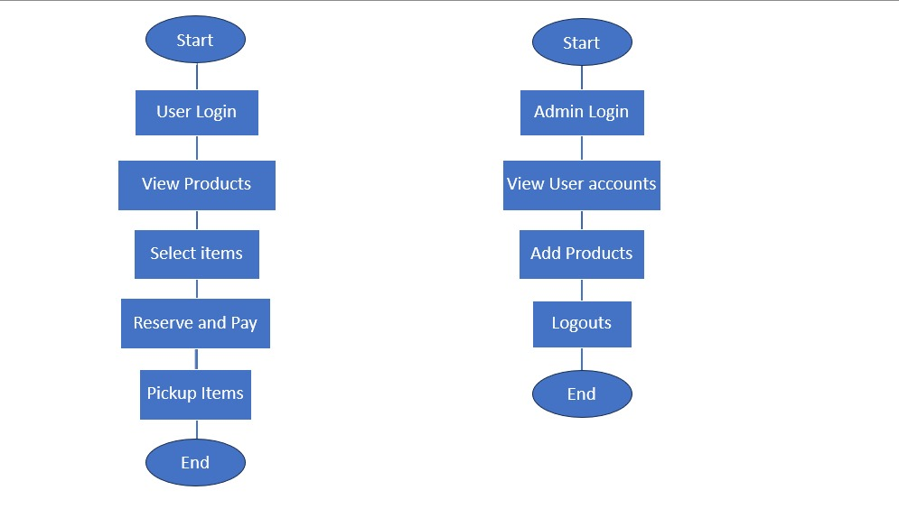

Admin Flow

User Flow

Fig 5.1

The provided diagram appears to be a flowchart for a system involving user registration, authentication, and other related processes. Here's a description of the chart's components:

**Key Steps:**

1. **Start**
   * The process begins when the user accesses the system.
2. **User Login**
   * The user is required to log in with valid credentials (username/email and password).
   * If the credentials are incorrect, the user is prompted to try again or recover their password.
3. **View Products**
   * After logging in, the user is presented with a catalog of products available in the store.
   * Products are organized with categories, filters (price, availability), and search options for easier navigation.
4. **Select Items**
   * The user can browse the list of products and select items they want to reserve.
   * Quantities of items can be specified at this step.
5. **Reserve and Pay**
   * Once the user finalizes their selection, they proceed to the reservation process.
   * The system displays the total price, and the user is redirected to a secure payment gateway.
   * Payment methods include credit/debit cards, UPI, or digital wallets.
   * Upon successful payment, a confirmation message is sent via email/SMS, including reservation details.
6. **Pickup Items**
   * The user visits the store at the scheduled time to pick up the reserved items.
   * Reservation details can be shown (e.g., receipt, QR code) to collect the items.
7. **End**
   * The process concludes after the successful pickup of items.

**Admin Process Flow**

1. **Start**
   * The process begins when the admin accesses the system.
2. **Admin Login**
   * The admin logs in using secure credentials to access the system backend.
   * Access is restricted to authorized admins only.
3. **View User Accounts**
   * The admin can view details of registered users, including reservation history, user activities, and payment records.
   * User account management options include enabling/disabling user access, deleting inactive accounts, or resetting passwords.
4. **Add Products**
   * The admin has the option to add new products to the catalog.
   * Product details include name, description, price, availability, and category.
   * Inventory updates reflect in real-time for users browsing the catalog.
5. **Logouts**
   * Once the required tasks are completed, the admin logs out securely from the system to prevent unauthorized access.
6. **End** – The process ends after the admin completes their activities and logs out.

**Use case Diagram:**

A use case diagram is used to represent the dynamic behavior of a system. It encapsulates the system's functionality by incorporating use cases, actors, and their relationships. It models the tasks, services, and functions required by a system/subsystem of an application. It depicts the high-level functionality of a system and also tells how the user handles a system.

Following are the purposes of a use case diagram given below:

* It gathers the system's needs.
* It depicts the external view of the system.
* It recognizes the internal as well as external factors that influence the system.
* 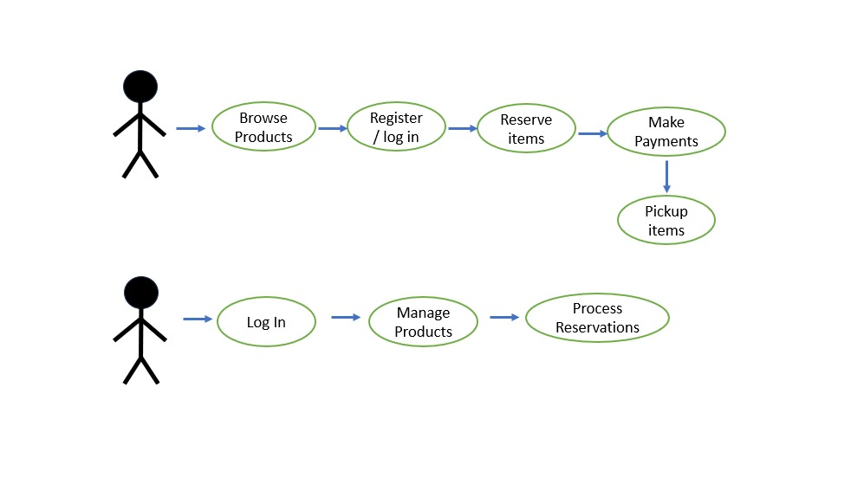It represents the interaction between the actors.

Fig 5.2

**Entity Relationship Diagram:**

* + ER model stands for an Entity-Relationship model. It is a high-level data model. This model is used to define the data elements and relationship for a specified system.
  + It develops a conceptual design for the database. It also develops a very simple and easy to design view of data.
  + In ER modelling, the database structure is portrayed as a diagram called an entity-relationship diagram.

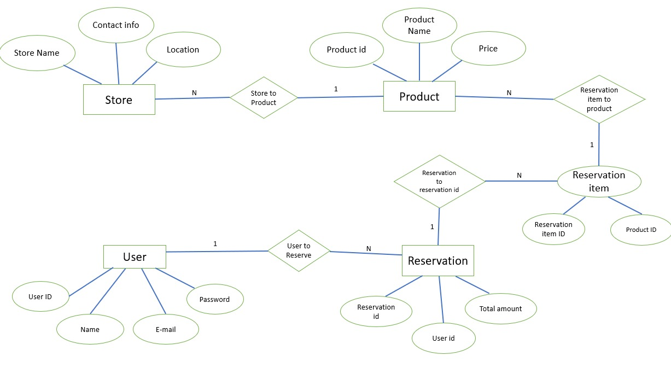

Fig 5.3

# Project Outcome

The *Reserve and Ready* project aims to create a seamless and efficient reservation management system that enhances the customer experience and streamlines operations for store owners. Below are the key outcomes of the project:

**1. Enhanced Customer Experience**

* **Convenient Product Reservations**:  
  Customers can reserve products online from a specific store without the need to physically visit the store. This feature is particularly beneficial for items in high demand or those with limited stock.
* **Secure Payment Integration**:  
  The system provides a smooth and secure payment integration for customers to pay for their reserved items.
* **Flexible Pickup Scheduling**:  
  Customers can choose a convenient pickup time for their reserved products, offering flexibility and improving the overall shopping experience. They can avoid long queues and get their items at the time that suits them best.

**2. Simplified Store Management**

* **Product Catalog Management**:  
  Store owners have the ability to easily add or update products in the system, manage pricing, and categorize items effectively. This improves the product visibility for customers and ensures the catalog stays up-to-date.
* **User Account Management**:  
  Admins can manage customer accounts. The system provides an easy-to-use interface for admins to review customer interactions and ensure smooth operations.

**3. Streamlined Operations**

* **Efficient Order Processing**:  
  The system minimizes manual work by automating the reservation and payment process. Orders are processed instantly after the payment is made, reducing wait times and enhancing the efficiency of store operations.
* **User-Friendly Interface for Both Users and Admins**:  
  The interface is designed to be intuitive and easy to navigate, ensuring that both customers and store administrators can use the system without extensive training.
* **Security Features**:  
  The system implements secure login protocols and payment encryption to ensure the safety of user data and financial transactions.

**4. Scalability and Future Enhancements**

* **Scalable Architecture**:  
  The system is designed to scale, allowing the addition of new features and support for multiple stores in the future. It can accommodate growing user bases and product catalogs as the business expands
* Future Enhancements: The system is designed to evolve and incorporate new features that meet future business needs, including:
* Advanced Analytics and AI: Future versions of the system can incorporate machine learning models for predictive analytics, offering store owners insights into consumer behavior, inventory trends, and demand forecasting.

**Home Page**:

The home page of **Reserve and Ready** serves as the platform's welcoming entry point, showcasing its tagline: **“Click, reserve, pick—it's that simple!”**. It highlights the core goal of simplifying wholesale purchasing through features like:

* A **search bar** for quick product access.
* A **navigation menu** with options for Home, Products, Admin, and Cart.
* A visually clean design promoting smart savings and efficient reservations.

This page ensures wholesale buyers experience a seamless and organized start to managing their bulk purchases.

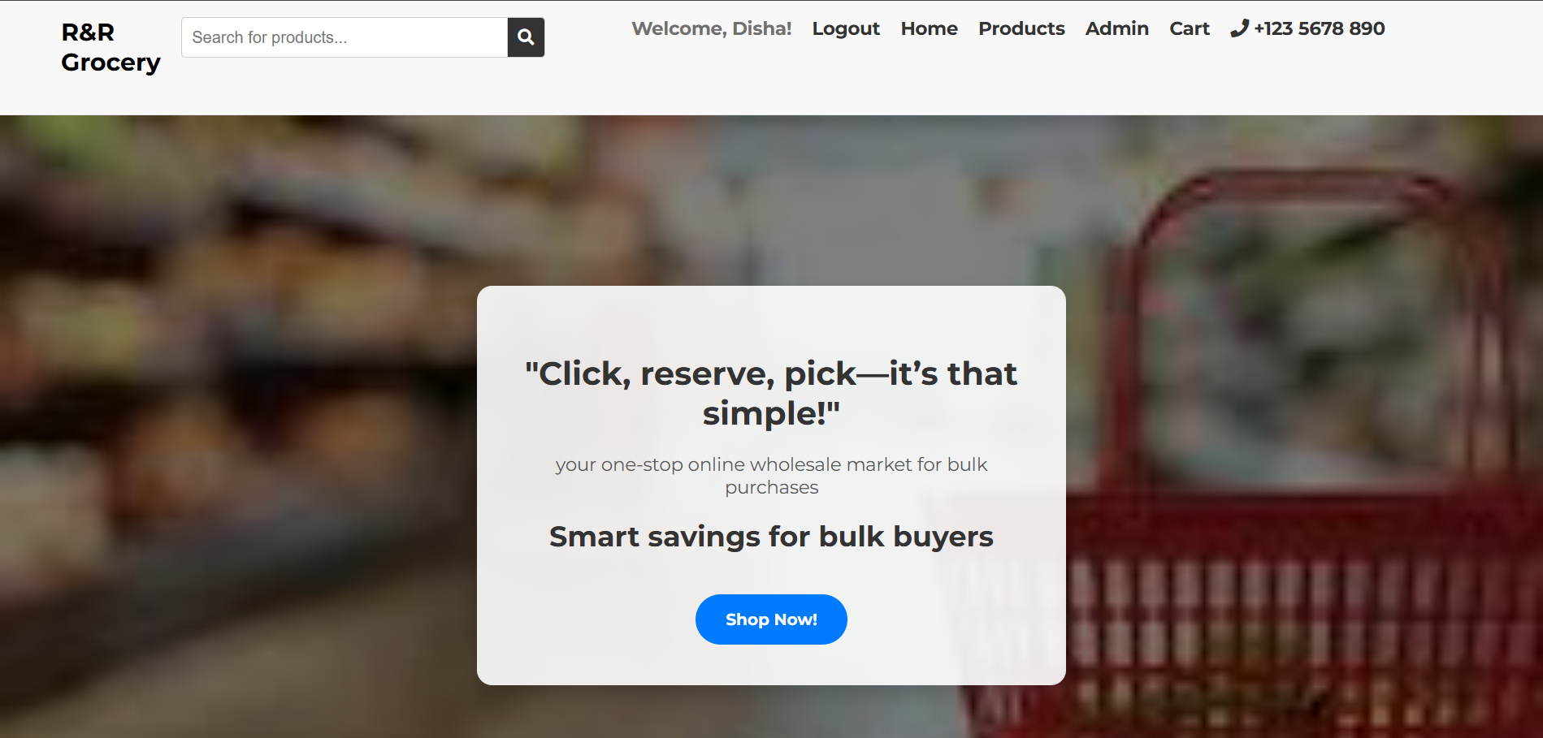

Fig 6.1

**Cart Page**:

The **Cart Page** serves as a critical touchpoint in the customer journey, offering a user-friendly interface for managing reservations. This page dynamically displays a comprehensive list of all items the user has reserved, along with key details such as product names, quantities, individual prices, and the total price.

**Key Features:**

1. **Item List Display**:  
   Users can see all the items they’ve added to their cart in an organized table format, ensuring clarity and ease of navigation. Each row represents a reserved item, complete with its price and quantity.
2. **Editing Options**:
   * **Remove Items**: Customers can easily remove unwanted items with a single click, keeping their cart streamlined and relevant.
3. 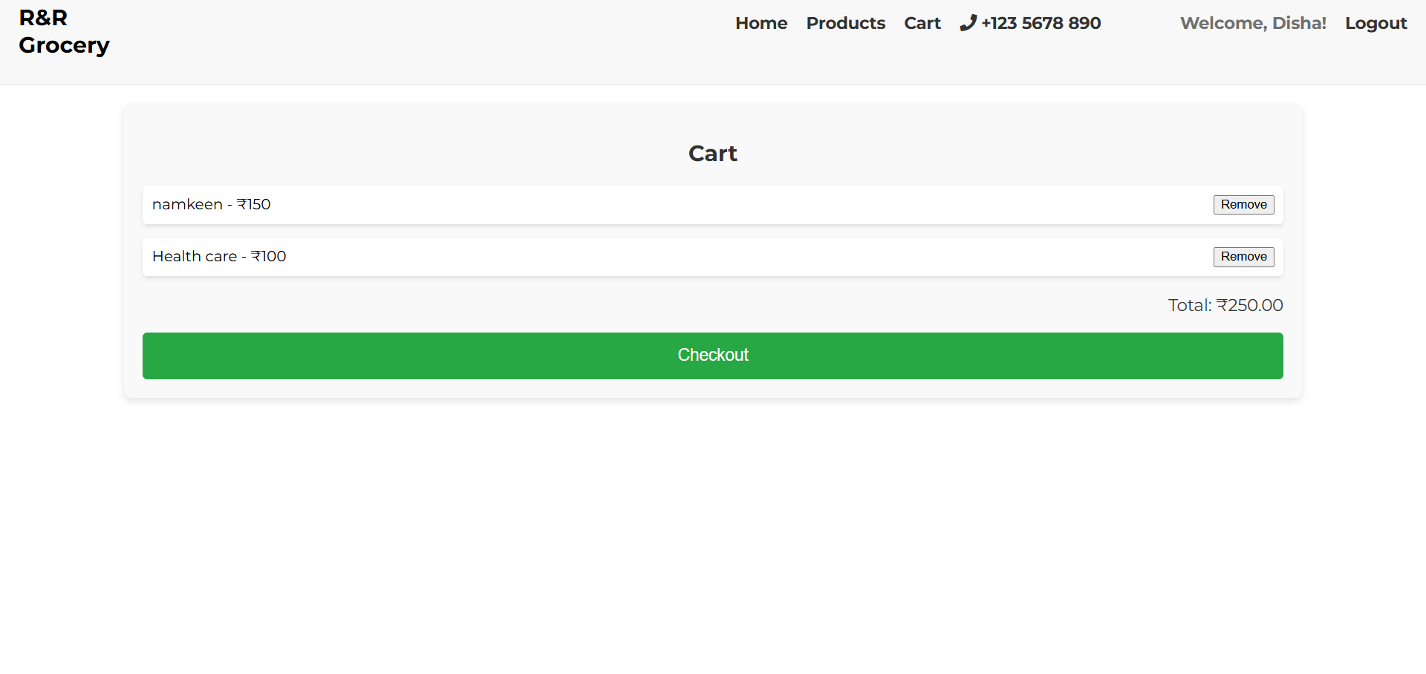**Total Cost Calculation**:  
   A real-time summary calculates the total cost of all items in the cart, allowing users to make informed decisions before proceeding to checkout.

Fig 6.2

**Payment Page:**

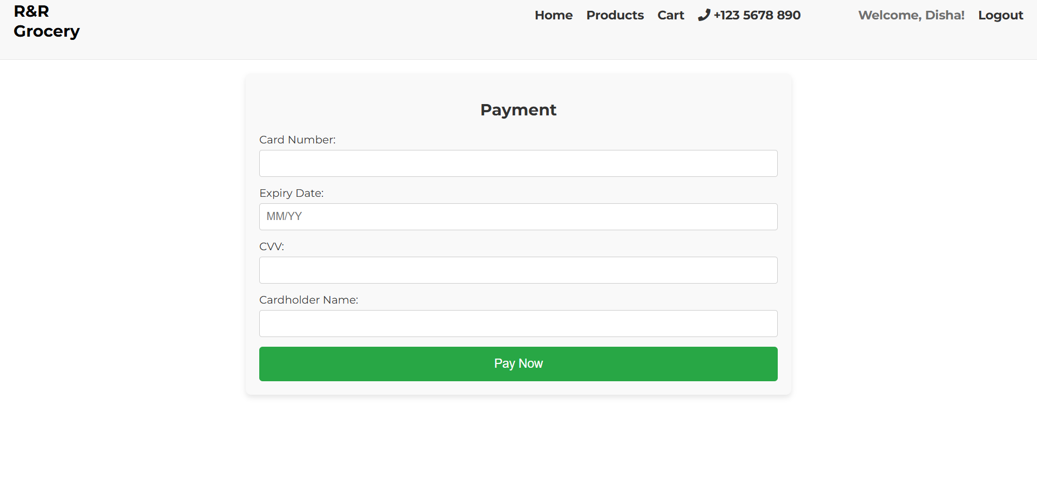

Fig 6.3

**The Payment Page** of **Reserve and Ready** is designed to provide a seamless and secure checkout experience.

* **Form Fields**: Includes input fields for essential payment details:
  + Card number
  + Expiry date
  + CVV
  + Cardholder name
* **Pay Now Button**: A clearly visible **“Pay Now”** button ensures users can complete their transaction with ease.
* **Layout**: The page is clean, intuitive, and user-friendly, prioritizing simplicity to reduce friction in the payment process.
* **Security**: Emphasizes secure payment processing to build user trust and confidence in the platform

**Contact Page:**

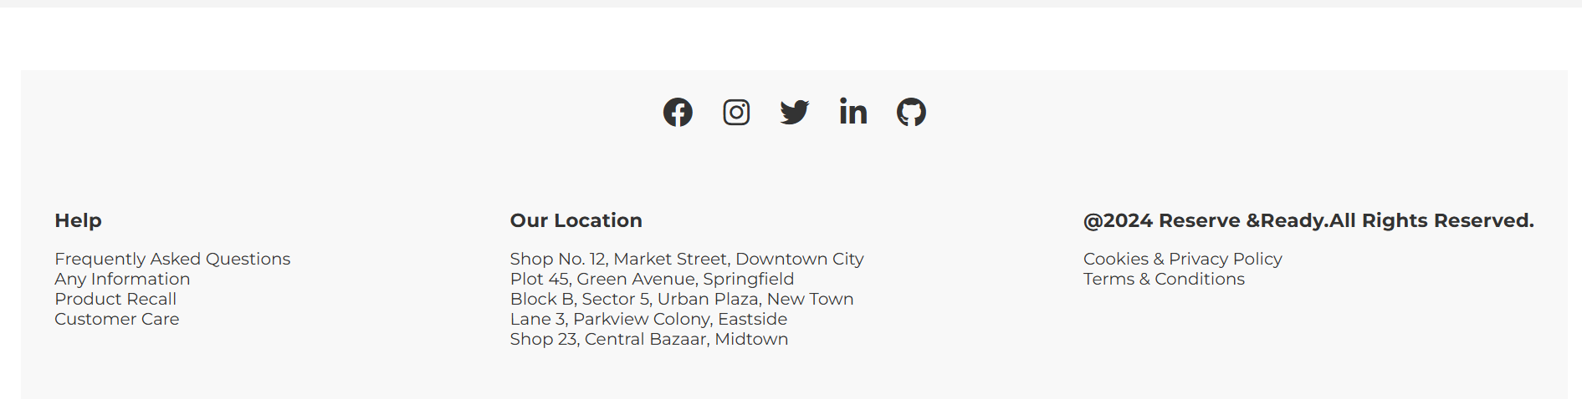 The **Contact Information Section** on **Reserve and Ready** offers users a variety of ways to reach out for support or inquiries.

* **Details Provided**:

Fig 6.4

* + **Email Address**: For addressing detailed queries or providing feedback.
  + **Phone Number**: For immediate assistance or urgent support needs.
  + **Physical Location**: Displays the business address to establish credibility and transparency.
* **Purpose**:  
  This section ensures users feel supported and connected, enhancing trust in the platform. It provides clear and accessible communication channels for resolving issues or sharing inquiries.
* **User Experience**:  
  Designed with clarity, the section ensures users can quickly find the appropriate contact information, making it a reliable support hub for customers and stakeholders.

**Products Catalog:**

This is the "Our Products" page for a retail or wholesale e-commerce platform. It displays a grid of products with images, names, prices, and an "Add to Cart" button for each item, making the user interface clean and easy to navigate. The products include groceries, personal care items, and household essentials like almond oil, kitchen utensils, soap, and peanut butter. Each product card highlights the price in red for visibility and ensures users can quickly add items to their shopping cart. The layout is visually organized, with a consistent design for all items, enhancing the overall user experience and accessibility.

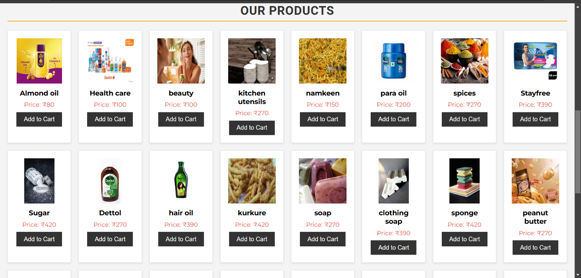

Fig 6.5

**Payment Confirmation:**

This is a payment confirmation page displayed after a successful transaction. It includes the following key elements:

A "Payment successful!" message, acknowledging the user's completed purchase.

A thank you note to express appreciation for the purchase.

A hyperlinked text labelled "Click here" that provides users with an option to manually return to the homepage.

An auto-redirect message indicating the user will be automatically taken back to the homepage in 10 seconds if no action is taken.

The page design is minimal, ensuring the focus remains on the confirmation and next steps without distractions.

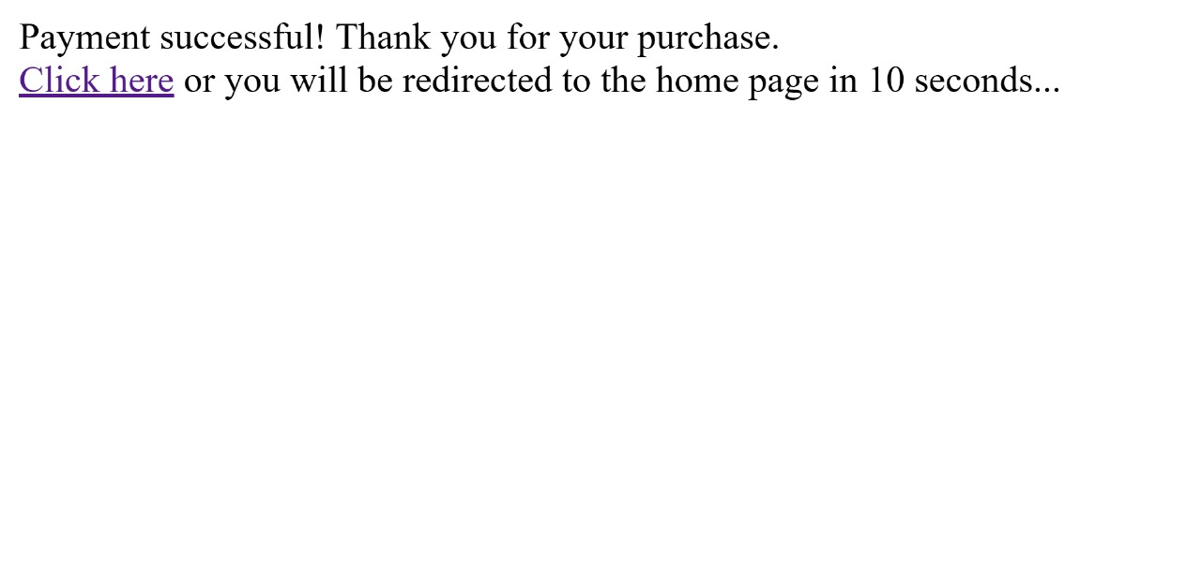

Fig 6.6

**Login Page:**

This is a Login Page designed for a web application. It features a simple, clean, and user-friendly interface with a minimalist design. The page contains:

* Username Input Field – where users enter their unique username.
* Password Input Field – a secure field to input the user's password.
* Login Button – allows users to submit credentials to log into the application.
* Register Button – provides users an option to navigate to the registration page to create a new account.

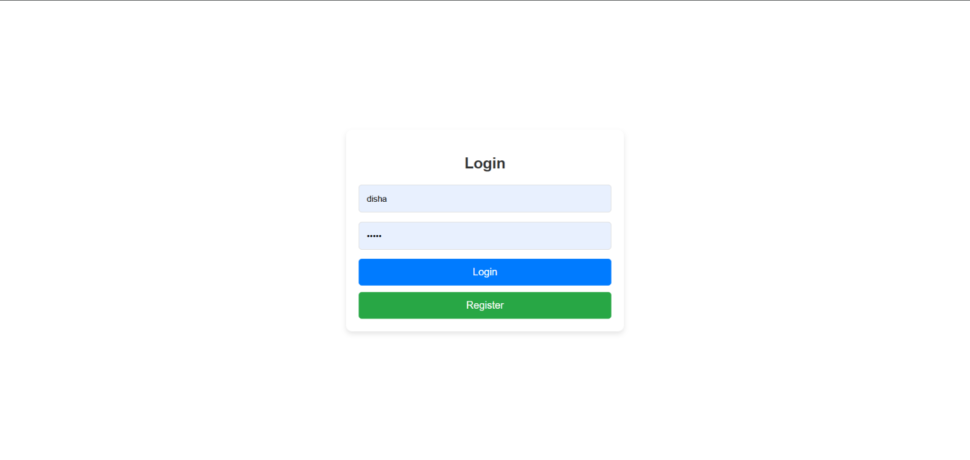

Fig 6.7

**Admin Dashboard :**

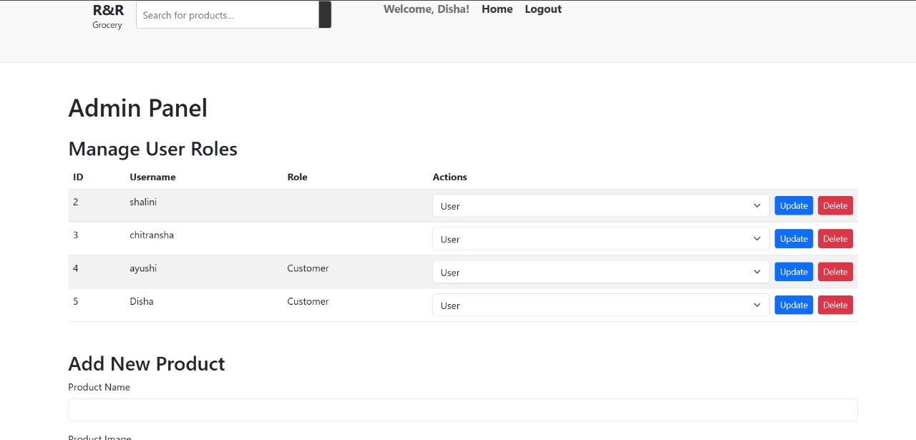

Fig 6.8

This is an Admin Panel Page designed for managing user roles and adding new products. The page consists of two main sections:

Manage User Roles

Displays a table with user details including ID, Username, and Role.

Admin can perform actions like:

Update: Modify the user's role using a dropdown menu.

Delete: Remove a user from the system.

The table includes action buttons with a clean design: blue for "Update" and red for "Delete" to distinguish functionalities clearly.

Add New Product

This section provides input fields for adding new product details like "Product Name" and "Product Image."

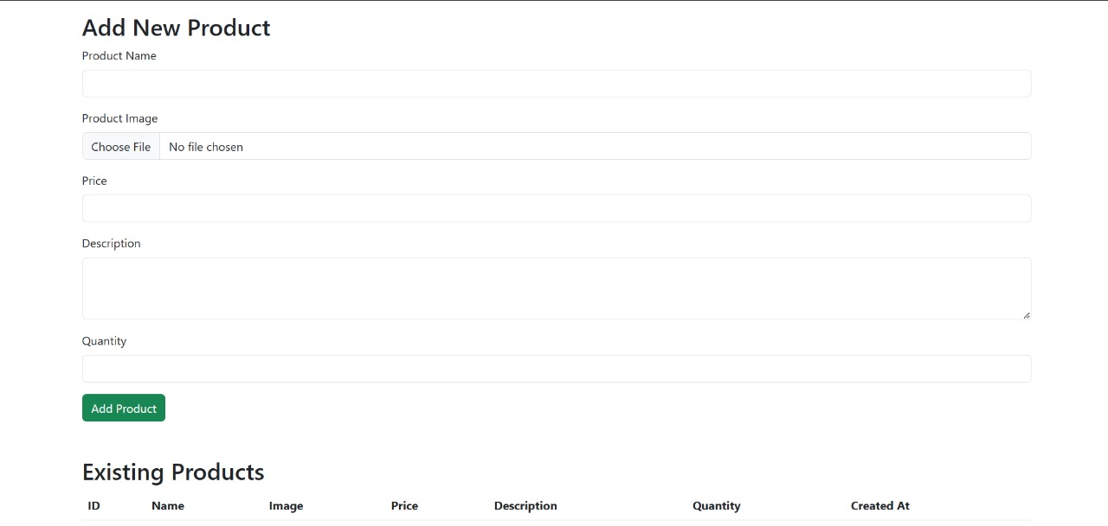It facilitates adding products to the system, reflecting the admin's ability to manage store content efficiently.

Fig 6.9

**Existing Products**

A table layout (not fully visible) is provided to display the list of existing products.

Columns in the table include:

1. ID: Unique identifier for each product.
2. Name: Product name.
3. Image: Visual representation of the product.
4. Price: Product cost.
5. Description: Product details.
6. Quantity: Available stock.
7. Created At: Timestamp of product creation.

## REFERENCES

# 

1. Rao, A., Singh, R. K., and Srivastava, N., "In-band Full-duplex Radio: A Survey," *International Journal of Applied Engineering Research*, vol. 1, pp. 81-86, 2019.
2. Sawyer, S., and Guinan, P. J., "Software Development: Processing and Performance," *BM Systems Journal*, vol. 37, no. 4, pp. 552-569, 1998.
3. Snijders, R., "Crowd-Centric Requirements," in *International Conference on Utility and Cloud Computing*, pp. 614-615, 2014.
4. Lee, H., et al., "Optimal Beamforming Designs for Wireless Information and Power Transfer in MISO Interference Channels," *IEEE Transactions on Wireless Communications*, vol. 14, no. 9, pp. 4810-4821, 2015.
5. Marsch, P., and Fettweis, G. P., *Coordinated Multi-Point in Mobile Communications: From Theory to Practice*. Cambridge University Press, 2011.
6. Nintanavongsa, P., Muncuk, U., Lewis, D. R., and Chowdhury, K. R., "Design Optimization and Implementation for RF Energy Harvesting Circuits," *IEEE Journal on Emerging and Selected Topics in Circuits and Systems*, vol. 2, no. 1, pp. 24-33, 2012.
7. Mitola III, J., "Cognitive Radio: An Integrated Agent Architecture for Software Radio," Ph.D. dissertation, Royal Institute of Technology (KTH), Stockholm, Sweden, 2000.
8. Clancy, T. C., "Achievable Capacity Under the Interference Temperature Model," in *IEEE INFOCOM 2007 - 26th IEEE International Conference on Computer Communications*, pp. 794-802, 2007.
9. Pandharipande, A., and Linnartz, J-P. M. G., "Performance Analysis of Primary User Detection in a Multiple Antenna Cognitive Radio," in *2007 IEEE International Conference on Communications*, pp. 6482-6486, 2007.
10. Pérez-Romero, J., Sallent, O., Agustí, R., and Giupponi, L., "A Novel On-Demand Cognitive Pilot Channel Enabling Dynamic Spectrum Allocation," in *2007 2nd IEEE International Symposium on New Frontiers in Dynamic Spectrum Access Networks*, pp. 46-54, 2007.
11. Cabric, D., Tkachenko, A., and Brodersen, R. W., "Experimental Study of Spectrum Sensing Based on Energy Detection and Network Cooperation," in *Proceedings of the First International Workshop on Technology and Policy for Accessing Spectrum*, p. 12, ACM, 2006.
12. DARPA, ATO., "Next Generation (XG) Program," [Online]. Available: http://www.darpa.mil/ato/programs/xg/index.htm, 2002.